**SSN College of Engineering**

**Department of Computer Science and Engineering**

**UCS1512 – Microprocessors Lab**

**EX:08 – Case Conversion**

Exp No: 08 Name : Kshitij Sharma

Date: 15/10/2020 Reg No: 185001080

# Aim

To write a program for performing case conversion on the fly in an 8086 microprocessor using MASM and DOSBox.

# Algorithm

1. Define the values in the data segment and assign the counter value
2. Initialize the data segment register with a data segment address
3. Load the loop counter value into CX which determines how many inputs for case conversion can be given by the user before the program terminates
4. Repeat till CX becomes zero:
   1. Call the DOS Interrupt Function 21H with AH = 01H to read a single character keyboard input with echo into AL whose value will lie in the range:
      * ASCII(hex) : A - Z = 41 - 5A, a - z = 61 - 7A
      * ASCII(dec) : A - Z = 65 - 90, a - z = 97 - 122
   2. Check if the character was uppercase or lowercase using CMP:
      * Uppercase: < 60H which is (dec)96
      * Lowercase: > 60H which is (dec)96
   3. If the character read was lower case, go to step 4.5
   4. If the character read was uppercase, convert to lowercase by adding 20H which is 32(dec):
      * A: 41H a:61H
      * a - A = 20H
   5. If the character read was lowercase, convert to uppercase by subtracting 20H which is 32(dec)

|  |  |
| --- | --- |
| **Program** | **Comments** |
| ASSUME CS:CODE,DS:data | Naming the CS and DS for the program |
| data SEGMENT  COUNT EQU 10h  data ends | When EQU refers to a constant value, it becomes a synonym for that value and this value can't be overwritten |
| CODE SEGMENT  org 0100h | Providing an offset value |
| START:  MOV AX,data MOV DS,AX | Initializing the data segment register with the data segment address |
| MOV CX,COUNT | Loading the count into CX for looping |
| L1:  MOV AH,1 INT 21H | Call the DOS Interrupt Function 21H with AH = 01H to read a single character keyboard input with echo into AL |
| CMP AL,60H JNC UPPER ADD AL,20H | Check if the character was uppercase or lowercase using CMP and jump if it was lowercase. Otherwise, convert to lowercase. |
| JMP SKIP | Skip to display if input was uppercase |
| UPPER:  SUB AL,20H | Convert to uppercase when lowercase input is detected |
| SKIP:  MOV AH,2 MOV DL,AL INT 21H LOOP L1 | Display the converted character by calling the DOS Interrupt Function 21H with AH = 02H to display a single character stored in DL |

* 1. Display the converted character by calling the DOS Interrupt Function 21H with AH = 02H to display a single character stored in DL

|  |  |
| --- | --- |
| MOV Ah,4CH | Calling the DOS Interrupt Function 21H with |
| INT 21H | AH = 4CH to terminate the program |
| CODE ENDS |  |
| end start |  |

1. Terminate the program by calling the DOS Interrupt Function 21H with AH = 4CH

# Snapshot

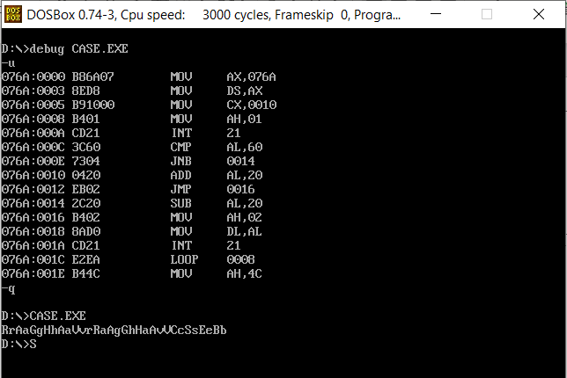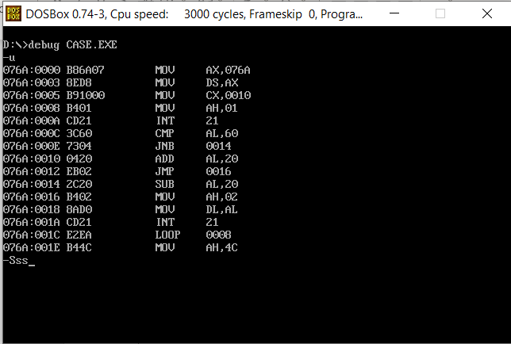

**Result**

Program for performing case conversion on the fly in an 8086 microprocessor using MASM and DOSBox was implemented and the output was verified.